Minor Chord
# Source: AI Source: Provided by: [Data Path: Persons Table -> ID Column: 1, Name_En Column: Motasem Essam] -> From: [ChatGPT] on [7/25/2026]
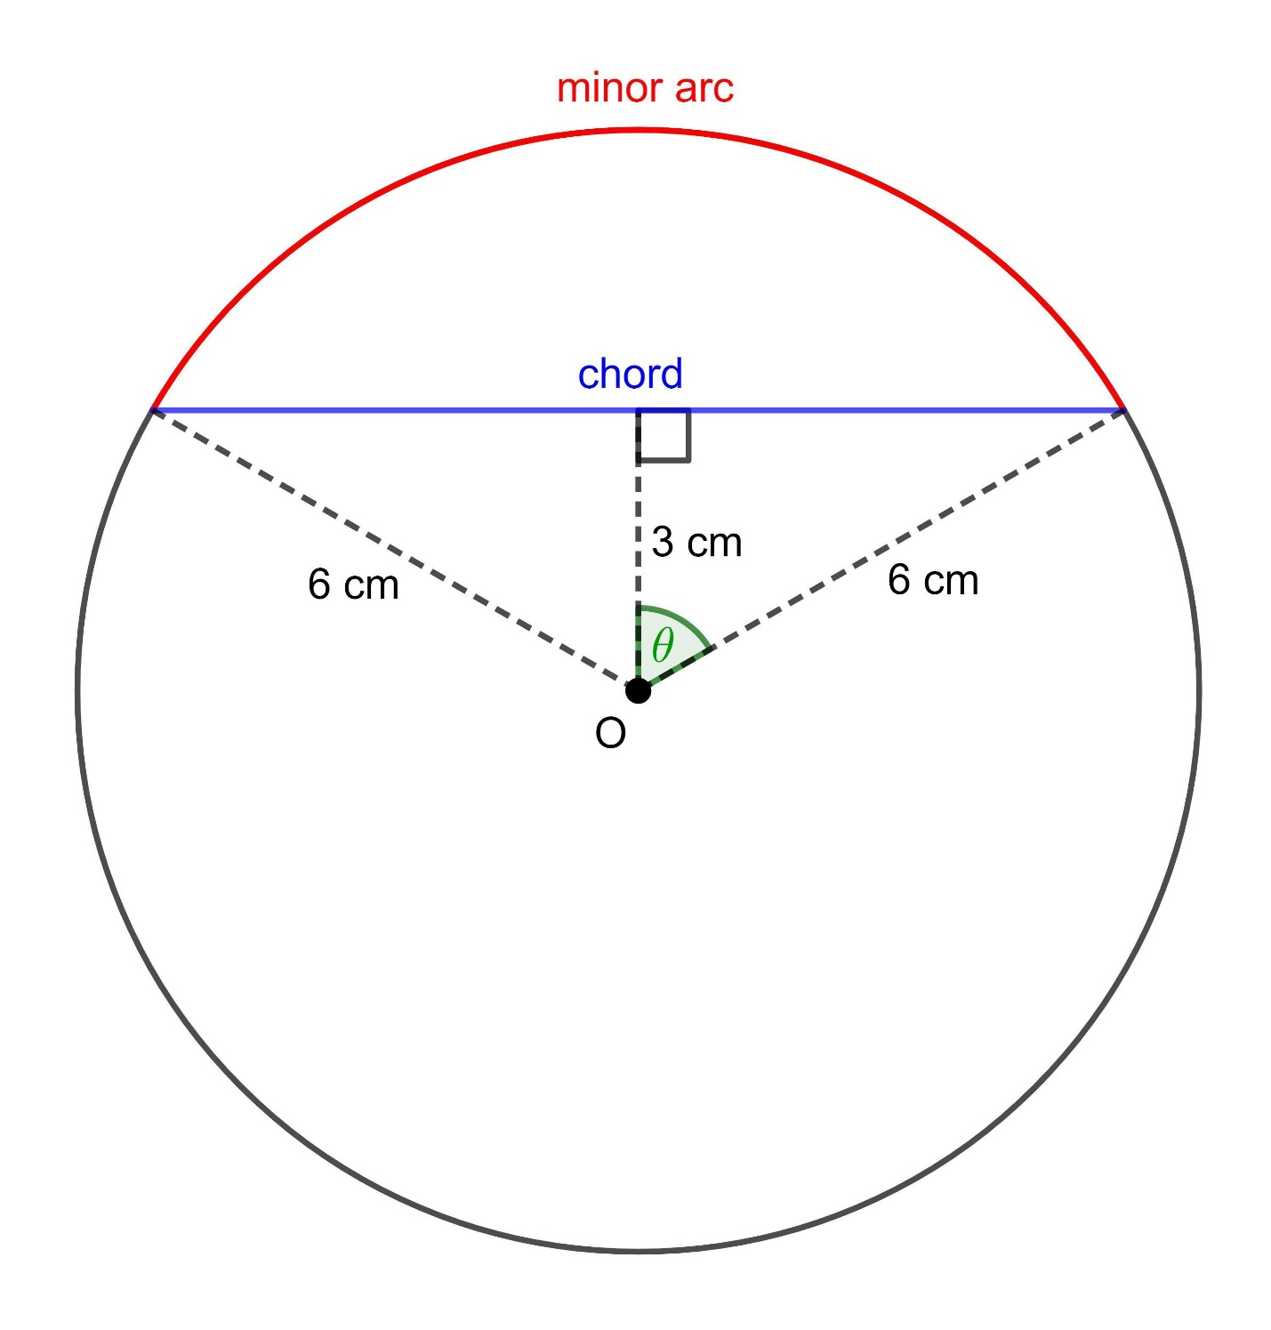
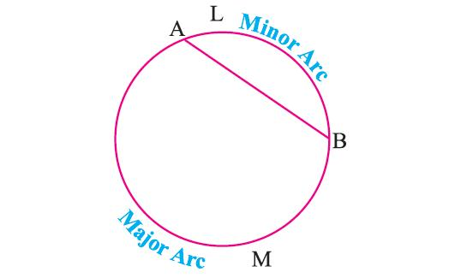
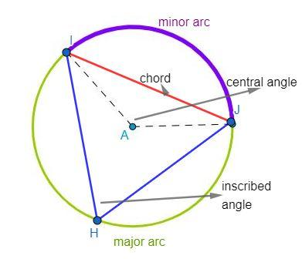

Definition
# Source: AI Source: Provided by: [Data Path: Persons Table -> ID Column: 1, Name_En Column: Motasem Essam] -> From: [ChatGPT] on [7/25/2026]
A Minor Chord is a chord that connects two points on a circle and is associated with the minor arc between those two points.
The chord itself is a straight line segment; the term minor describes the shorter arc determined by its endpoints.
If $A$and $B$are points on a circle and the minor arc between them is $\hat{AB}$, then:
$$\overset{‾}{AB}$$
is the chord corresponding to that minor arc.
Important: In formal geometry, minor chord is not usually treated as a fundamental separate type of chord. A chord is simply classified by the arc it subtends; the corresponding arc may be minor or major.

Fundamental Elements
# Source: AI Source: Provided by: [Data Path: Persons Table -> ID Column: 1, Name_En Column: Motasem Essam] -> From: [ChatGPT] on [7/25/2026]
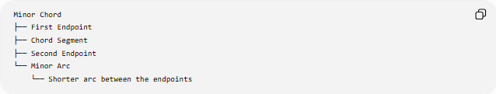
Minor Chord
├── First Endpoint
├── Chord Segment
├── Second Endpoint
└── Minor Arc
└── Shorter arc between the endpoints
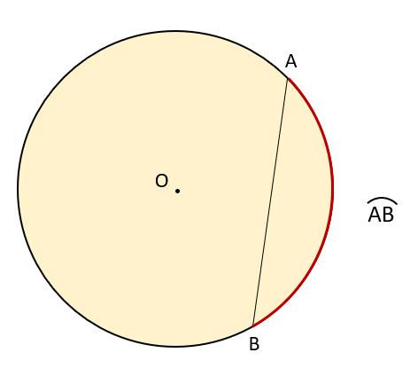
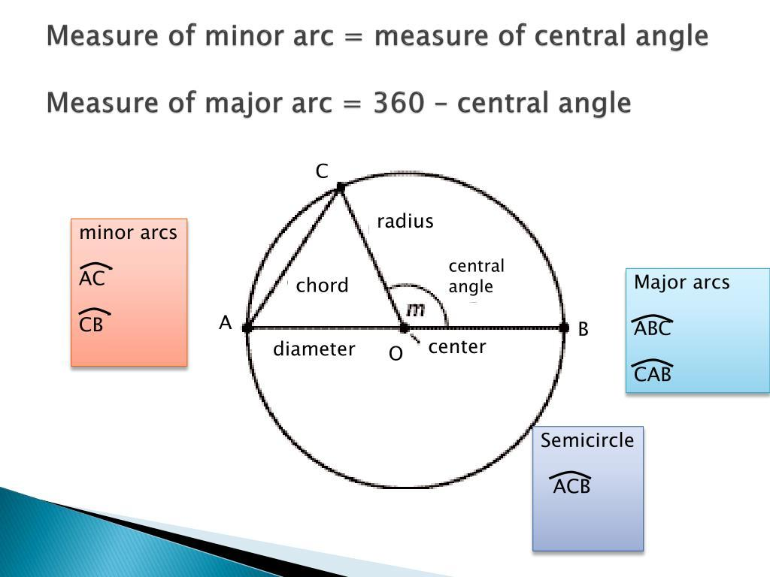

Main Properties
# Source: AI Source: Provided by: [Data Path: Persons Table -> ID Column: 1, Name_En Column: Motasem Essam] -> From: [ChatGPT] on [7/25/2026]
1. Both Endpoints Lie on the Circumference
For chord $\overset{‾}{AB}$:
$$A,B∈\text{circle}$$
2. The Chord Does Not Need to Pass Through the Center
If it does pass through the center, it becomes a diameter.
Therefore, a chord associated with a genuinely minor arc is always shorter than the diameter.
$$\boxed{L<d}$$
3. It Corresponds to a Minor Arc
A minor arc has a measure less than ${180}^{∘}$:
$$\boxed{m\left(\hat{AB}\right)<{180}^{∘}}$$
The chord connecting its endpoints is the corresponding minor-arc chord.
4. Shorter Arc → Shorter Chord
For the same circle, a smaller central angle produces a shorter chord.
If:
$$θ<{180}^{∘}$$
then the corresponding chord has length:
$$\boxed{L=2r\sin\left(\frac{θ}{2}\right)}$$

Minor Chord and Diameter
# Source: AI Source: Provided by: [Data Path: Persons Table -> ID Column: 1, Name_En Column: Motasem Essam] -> From: [ChatGPT] on [7/25/2026]
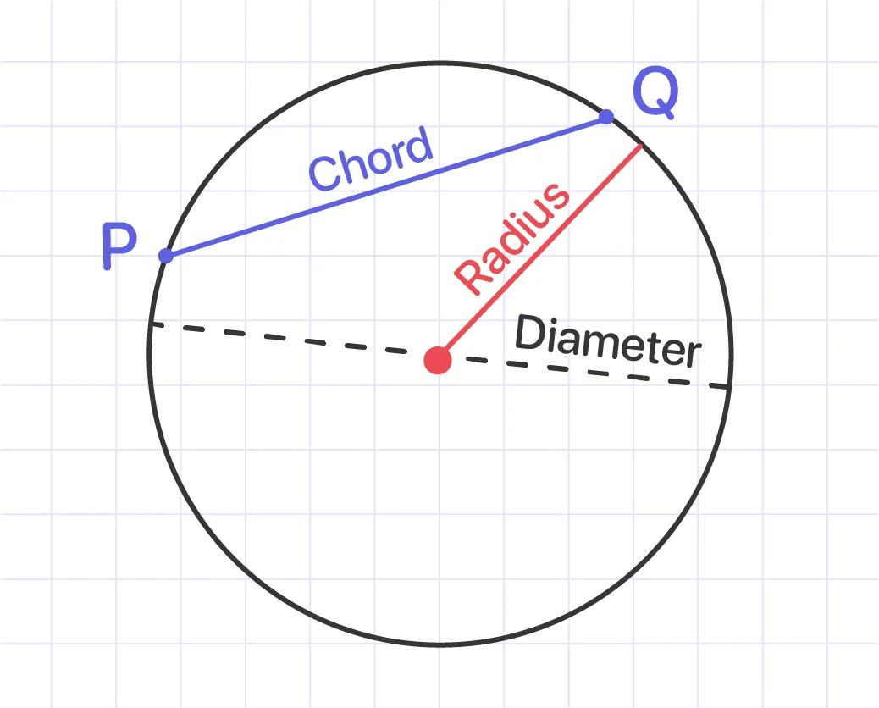
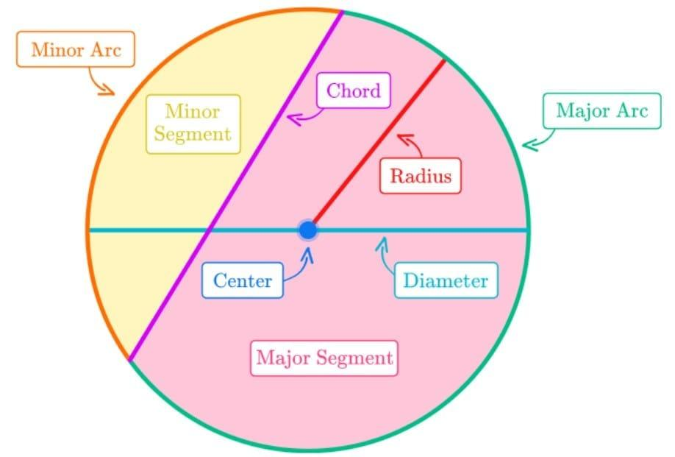
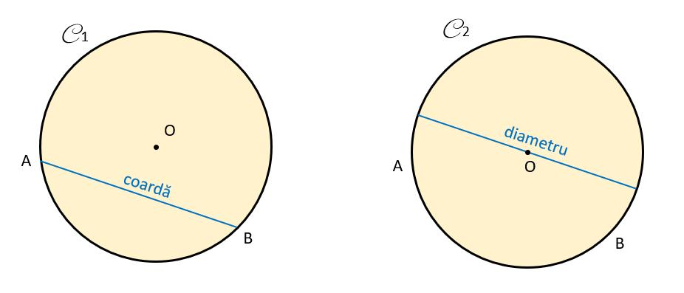
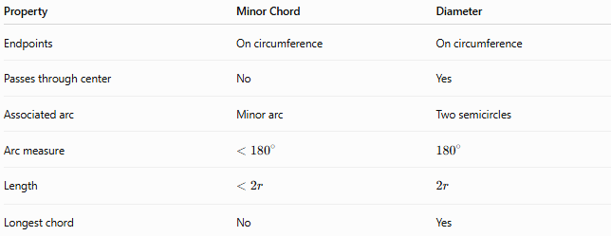
Property | Minor Chord | Diameter
Endpoints | On circumference | On circumference
Passes through center | No | Yes
Associated arc | Minor arc | Two semicircles
Arc measure | $$<{180}^{∘}$$ | $${180}^{∘}$$
Length | $$<2r$$ | $$2r$$
Longest chord | No | Yes

Minor Chord vs Minor Arc
# Source: AI Source: Provided by: [Data Path: Persons Table -> ID Column: 1, Name_En Column: Motasem Essam] -> From: [ChatGPT] on [7/25/2026]
These two concepts should not be confused.
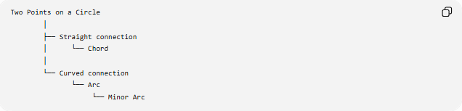
Two Points on a Circle
│
├── Straight connection
│ └── Chord
│
└── Curved connection
└── Arc
└── Minor Arc
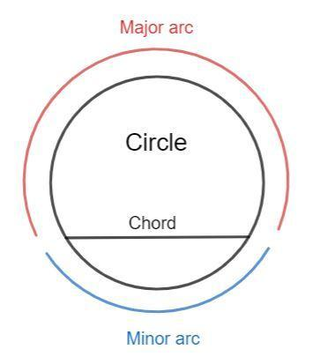
- Minor chord: straight segment between the two endpoints.
- Minor arc: shorter curved part of the circumference between the same endpoints.
Chord Length from Central Angle
If the circle has radius $r$and the minor arc subtends a central angle $θ$, then:
$$\boxed{L=2r\sin\left(\frac{θ}{2}\right)}$$
where $θ$is measured in degrees or radians consistently with the trigonometric calculation.
Example
For a circle with:
$$r=10\text{ cm}$$
and a minor central angle:
$$θ={60}^{∘}$$
the chord length is:
$$L=2\left(10\right)sin⁡\left({30}^{∘}\right) \\ L=20\left(\frac{1}{2}\right) \\ \boxed{L=10\text{ cm}}$$

Classification
# Source: AI Source: Provided by: [Data Path: Persons Table -> ID Column: 1, Name_En Column: Motasem Essam] -> From: [ChatGPT] on [7/25/2026]
For your knowledge-base taxonomy, I would structure this as:
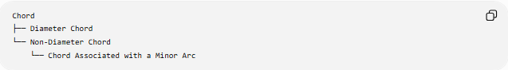
Chord
├── Diameter Chord
└── Non-Diameter Chord
└── Chord Associated with a Minor Arc
If you want to use Minor Chord as the displayed educational term, it can be written:
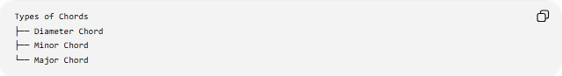
Types of Chords
├── Diameter Chord
├── Minor Chord
└── Major Chord
but the more mathematically precise terminology is chord corresponding to a minor arc. A chord itself is not inherently "minor" or "major" in the same standard way that arcs are.

Key Points
# Source: AI Source: Provided by: [Data Path: Persons Table -> ID Column: 1, Name_En Column: Motasem Essam] -> From: [ChatGPT] on [7/25/2026]
- A minor chord connects two points on a circle.
- It corresponds to a minor arc between those points.
- The corresponding arc has measure:
$$<{180}^{∘}$$
- It does not pass through the center.
- It is shorter than the diameter.
- Chord length can be calculated from the central angle using:
$$\boxed{L=2r\sin\left(\frac{θ}{2}\right)}$$

Conclusion
# Source: AI Source: Provided by: [Data Path: Persons Table -> ID Column: 1, Name_En Column: Motasem Essam] -> From: [ChatGPT] on [7/25/2026]
A Minor Chord is best understood as the straight segment joining the endpoints of a minor arc. For formal mathematical terminology, “chord corresponding to a minor arc” is more precise than treating “minor chord” as a fundamental chord category.

